**SCREENSHOT:**

**VLAN SETUP:**

SWITCH 1: Setting for IP Address:

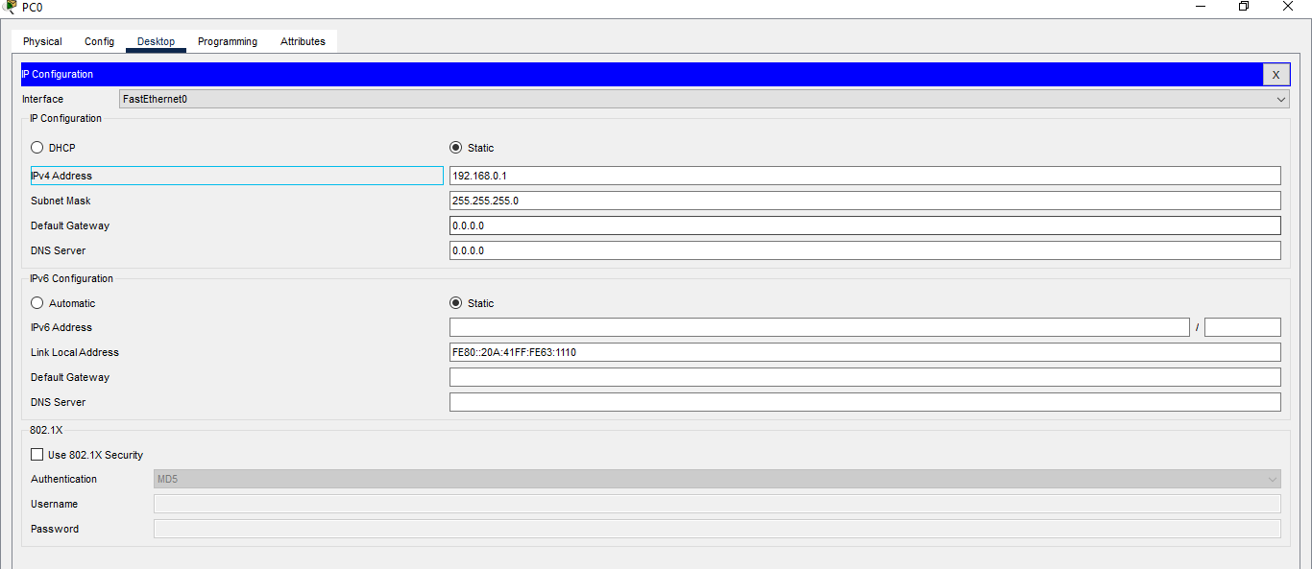

SWITCH 2: Setting for IP Address:

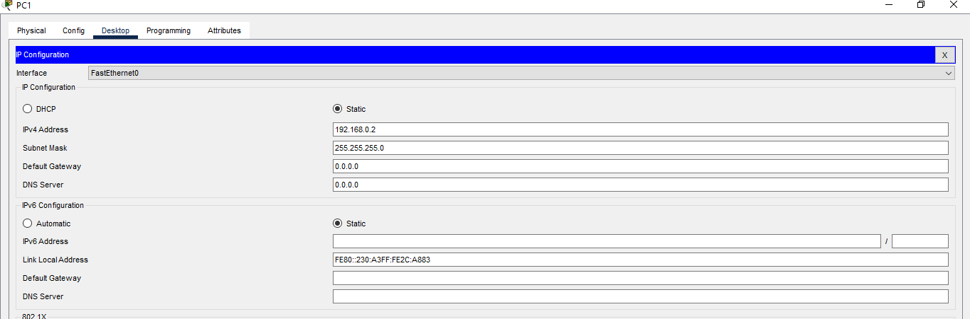

CLI for VLAN Setup:

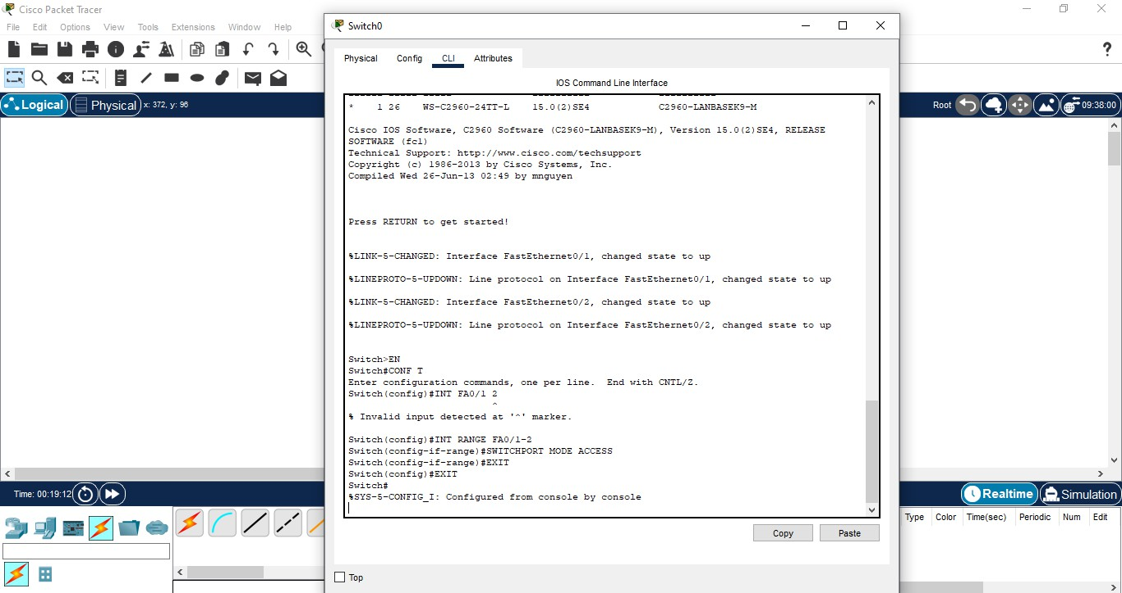

VLAN Setup Output:

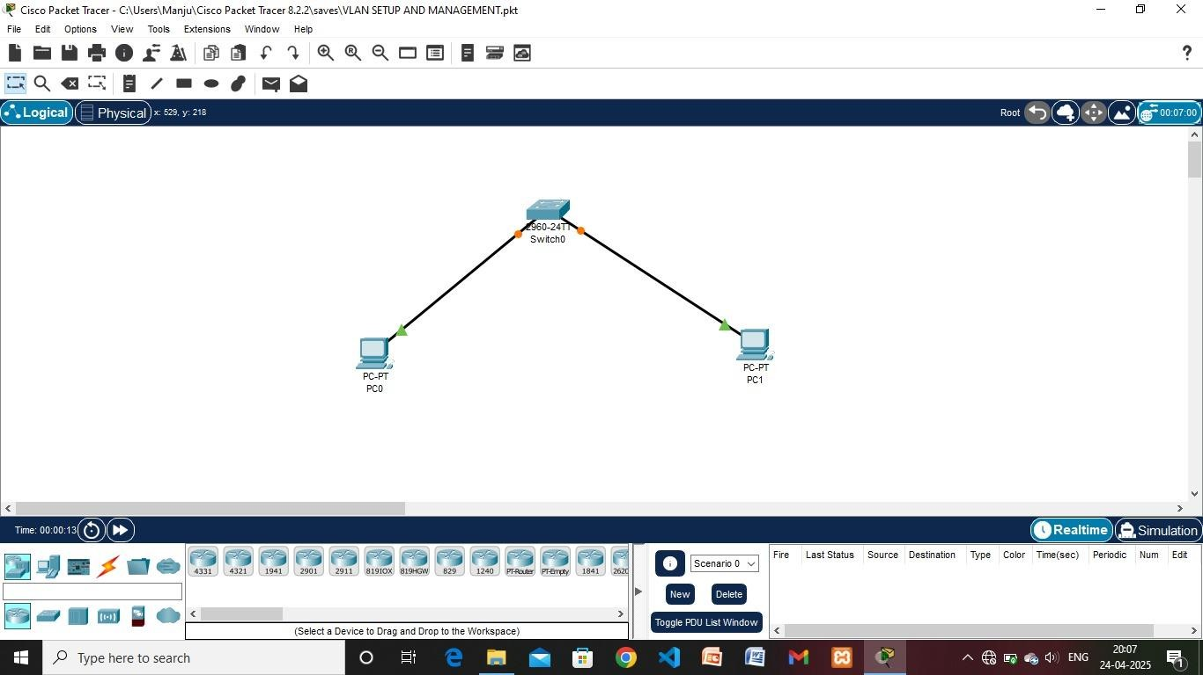

## VLAN Configurations and Trunking:

Command for VLAN Configuration

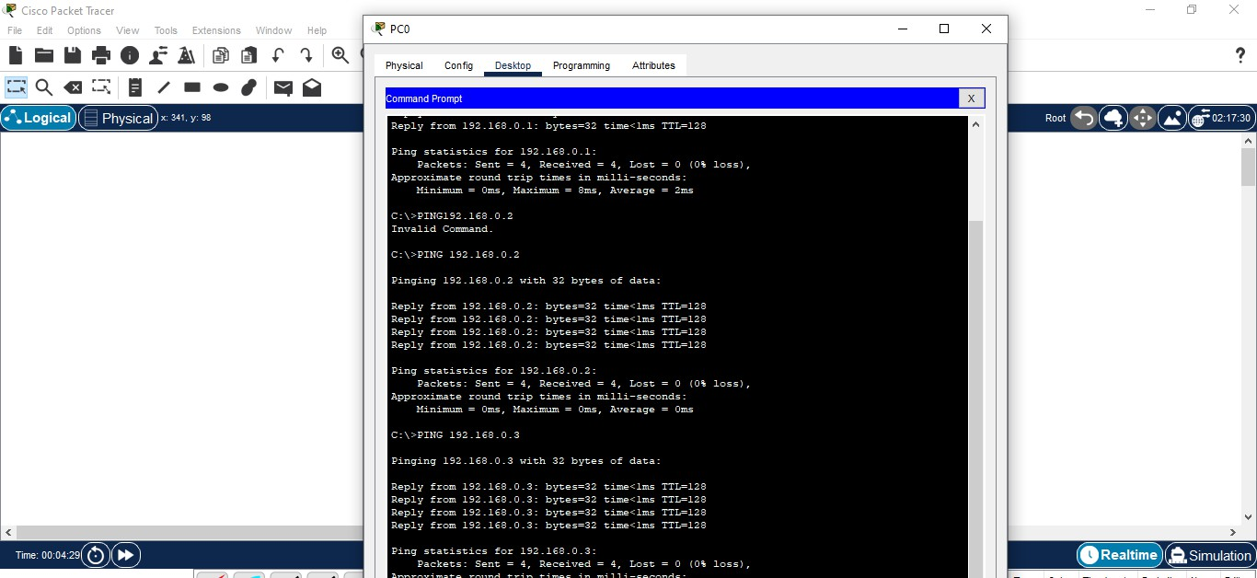

VLAN Configuration CLI

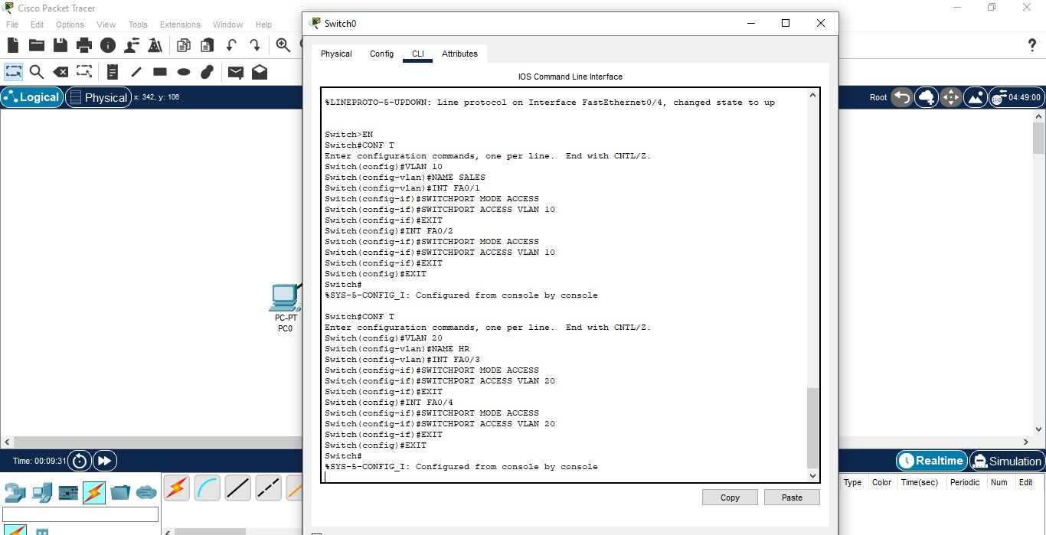

VLAN Configuration Output:

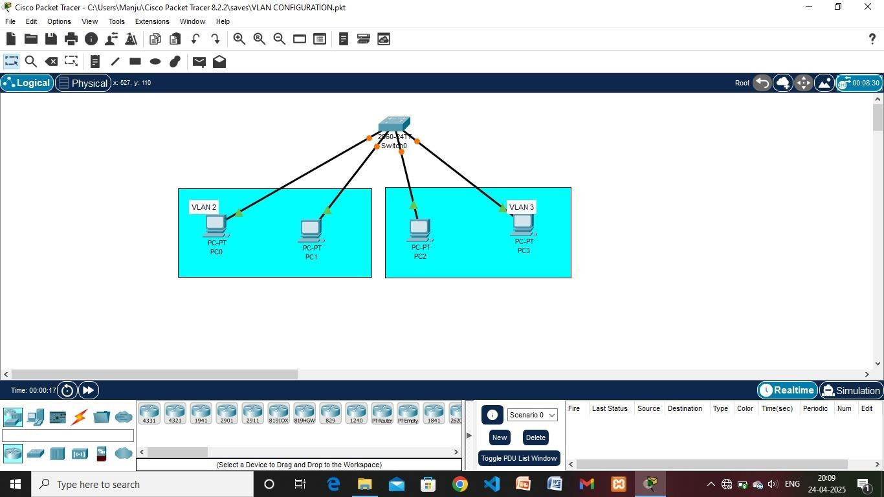

## Port Security:

Commands

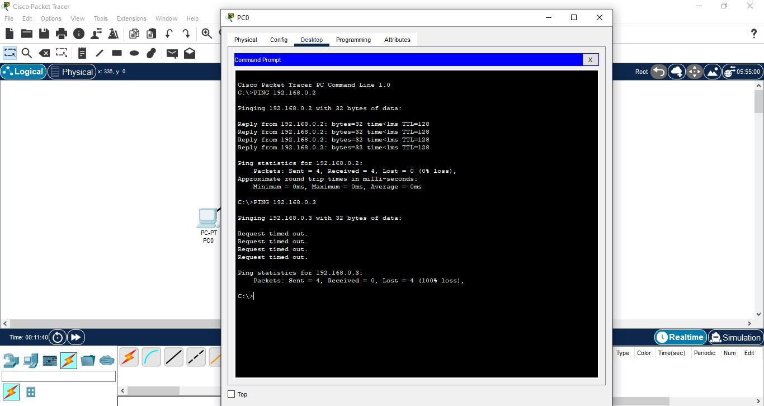

Port Security Output:

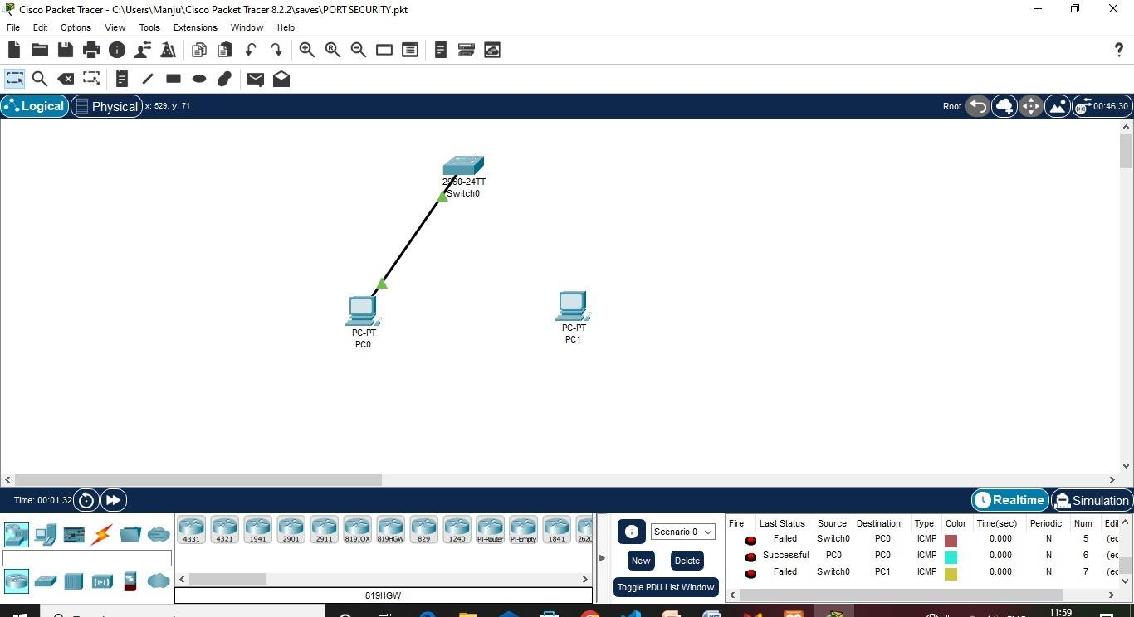

# ACL:

CLI:

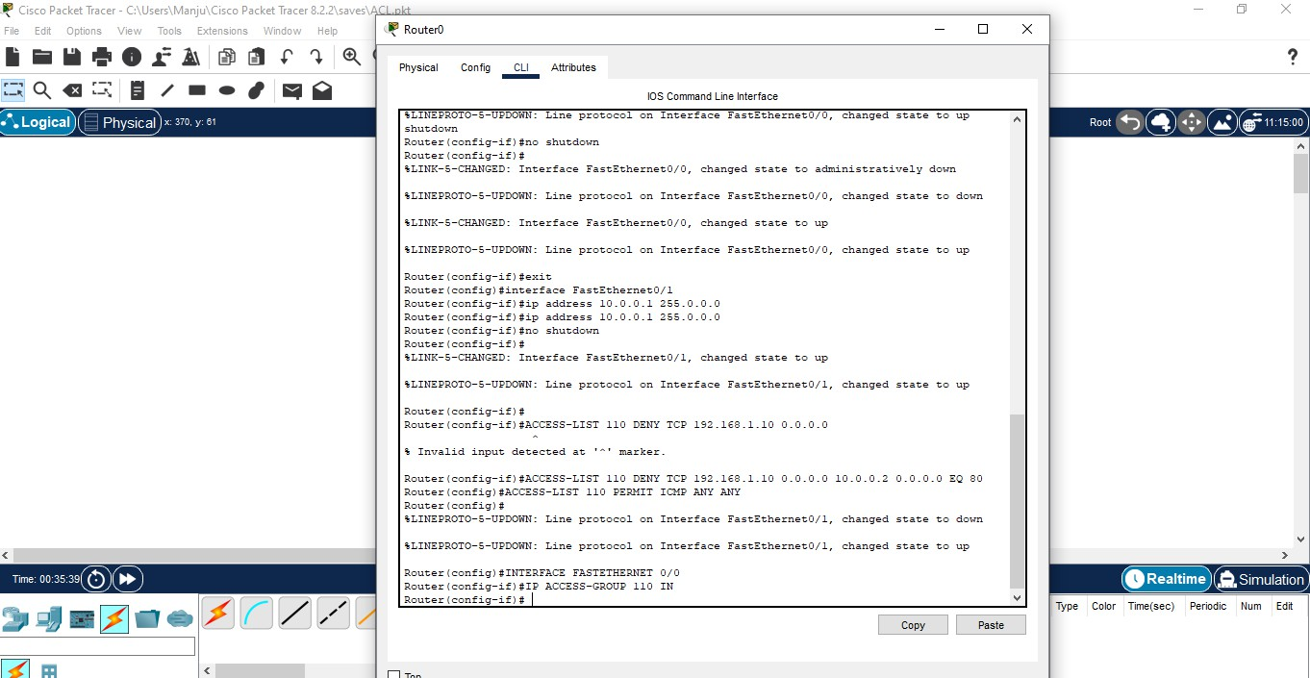

**ACL output:**

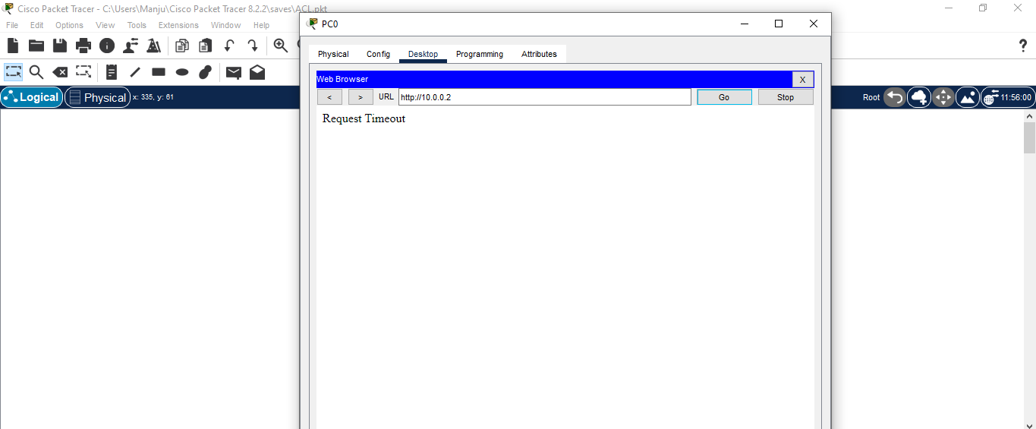

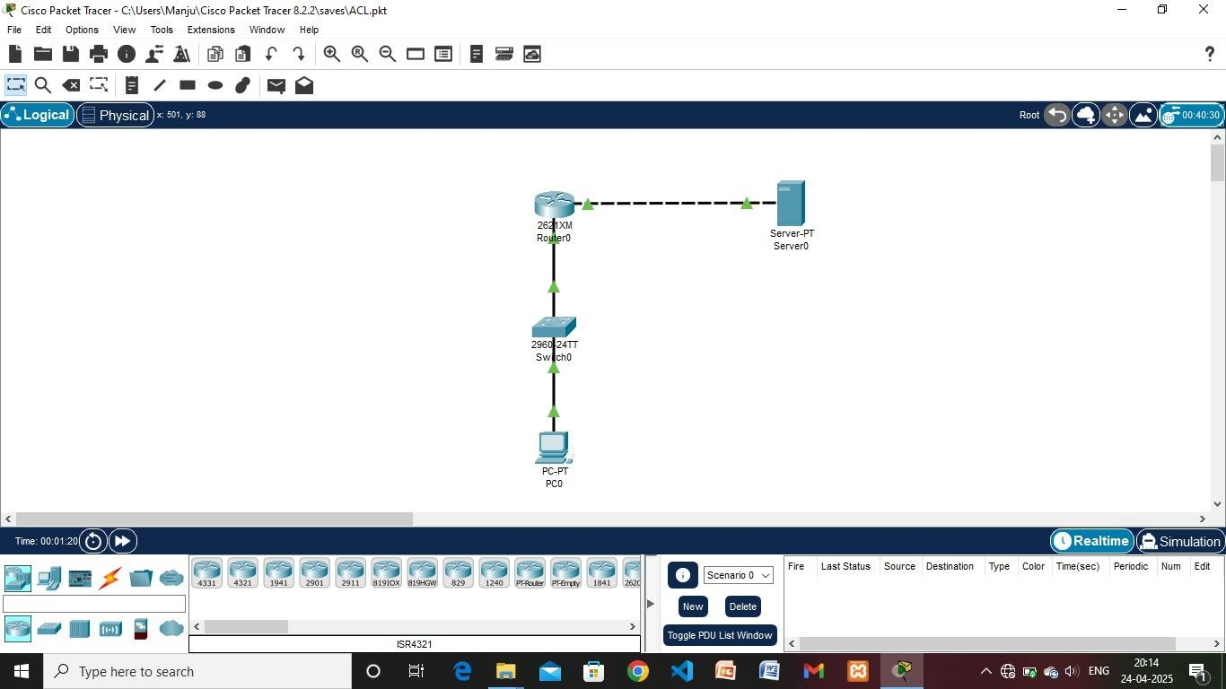

# SSH OUTPUT:

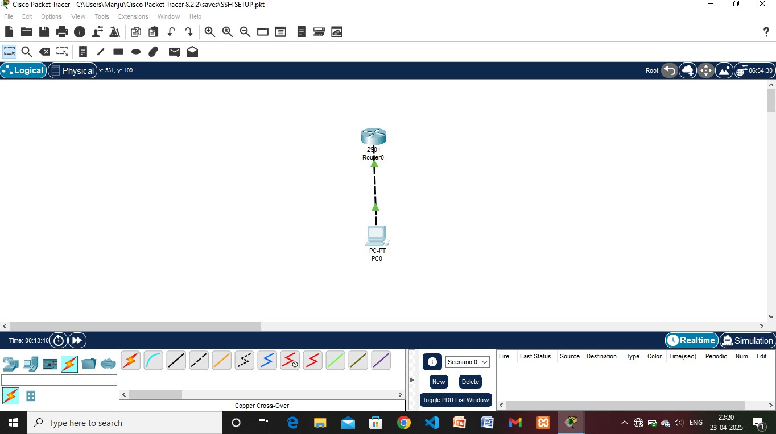

**SOURCE CODE**

# COMMAND LINE INTERFACE FOR VLAN SETUP:

Switch>EN

Switch#CONF T

Enter configuration commands, one per line. End with CNTL/Z. Switch(config)#INT RANGE FA0/1-2

Switch(config-if-range)#SWITCHPORT MODE ACCESS Switch(config-if-range)#EXIT

Switch(config)#EXIT Switch#

# COMMAND LINE INTERFACE FOR VLAN CONFIGUARATION:

Switch#EN Switch#CONF T

Enter configuration commands, one per line. End with CNTL/Z. Switch(config)#VLAN 2

Switch(config-vlan)#NAME SALES Switch(config-vlan)#INT FA0/1

Switch(config-if)#SWITCHPORT MODE ACCESS Switch(config-if)#SWITCHPORT ACCESS VLAN 2 Switch(config-if)#EXIT

Switch(config)#INT FA0/2

Switch(config-if)#SWITCHPORT MODE ACCESS Switch(config-if)#SWITCHPORT ACCESS VLAN 2 Switch(config-if)#EXIT

Switch(config)#EXIT Switch#

%SYS-5-CONFIG_I: Configured from console by console Switch#CONF T

Enter configuration commands, one per line. End with CNTL/Z. Switch(config)#VLAN 3

Switch(config-vlan)#NAME HR Switch(config-vlan)#INT FA0/3

Switch(config-if)#SWITCHPORT MODE ACCESS Switch(config-if)#SWITCHPORT ACCESS VLAN 3 Switch(config-if)#EXIT

Switch(config)#INT FA0/4

Switch(config-if)#SWITCHPORT MODE ACCESS Switch(config-if)#SWITCHPORT ACCESS VLAN 3 Switch(config-if)#EXIT

Switch(config)#EXIT

Switch#

%SYS-5-CONFIG_I: Configured from console by console Switch#

# COMMAND LINE INTERFACE FOR PORT SECURITY:

Switch>EN Switch#CONF T

Enter configuration commands, one per line. End with CNTL/Z. Switch(config)#INT FA0/2

Switch(config-if)#SWITCHPORT MODE ACCESS

Switch(config-if)#SWITCHPORT PORT-SECURITY

Switch(config-if)#SWITCHPORT PORT-SECURITY MAXIMUM 1 Switch(config-if)#SWITCHPORT PORT-SECURITY VIOLATION RESTRICT

Switch(config-if)#EXIT Switch(config)#EXIT Switch#

%SYS-5-CONFIG_I: Configured from console by console

# COMMAND LINE INTERFACE FOR ACCESS CONTROL LISTS:

Router>EN Router#CONF T

Enter configuration commands, one per line. End with CNTL/Z. Router(config)#ACCESS-LIST 110 192.168.1.10 0.0.0.0 10.0.0.2 0.0.0.0 EQ 80

^

% Invalid input detected at '^' marker.

Router(config)#ACCESS-LIST 110 PERMIT ICMP ANY ANY

Router(config)#INTERFACE FASTETHERNET 0/0 Router(config-if)#IP ACCESS-GROUP 110 IN Router(config-if)#EXIT

Router(config)#EXIT Router#